Test and Debug

# Part 1

|  |  |  |  |  |
| --- | --- | --- | --- | --- |
| Test ID | Test case scenario | Input | Expected output | Actual output |
| 1 | User enters the Integer to be an Email address | 21312 | Message Box: The email address must follow the form of the Email address. | Yes |
| 2 | User enters the decimal number to be an employee ID | 2.2 | Message Box: The employee ID must be an integer number | No |
| 3 | The user saves a new List to Data File while Data File has already got some data in there. | Add some data to List and then hit the button to save the List to the Data File | New data should be added to Data File and keep existing data still in the File. | Yes |

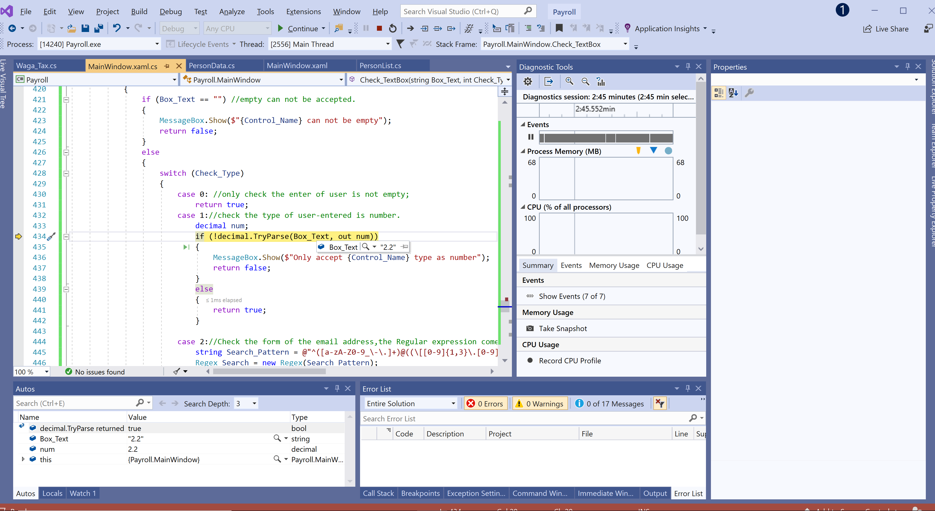

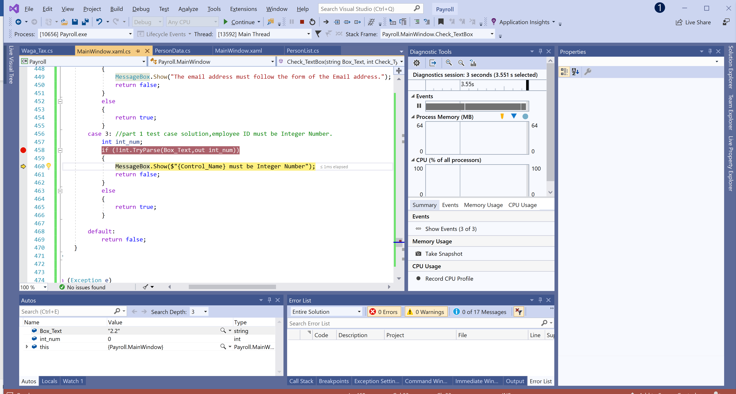

# Part 2

|  |  |  |  |  |
| --- | --- | --- | --- | --- |
| Test ID | Test case scenario | Input | Expected output | Actual output |
| 1 | User changes the pay rate of one item and save it. And then calculates its wages | Change pay rate of from 50 to 100 and save it, and then input its hours with 20, calculates its wage | Employee 23 Wage Details:  Pay rate is $50  Working hours is 100  Wage is $5000 | 1000 |
| 2 | User enters decimal number to calculate wages | ID = 201  Hours = 20.5 | Employee 211 Wage Details:  Pay rate is $23  Working hours is 20.5  Wage is $471.5 | Yes |
| 3 | User enters an ID without any items in list. | ID = 201  Hours = 50 | Employee 211 Wage Details:  Pay rate is $23  Working hours is 50  Wage is $1150 | Yes |

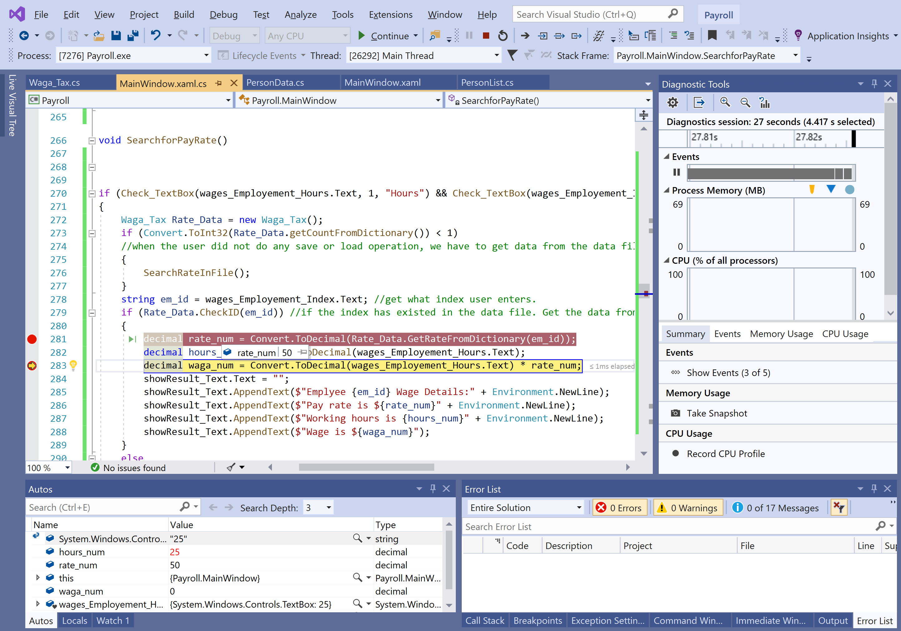

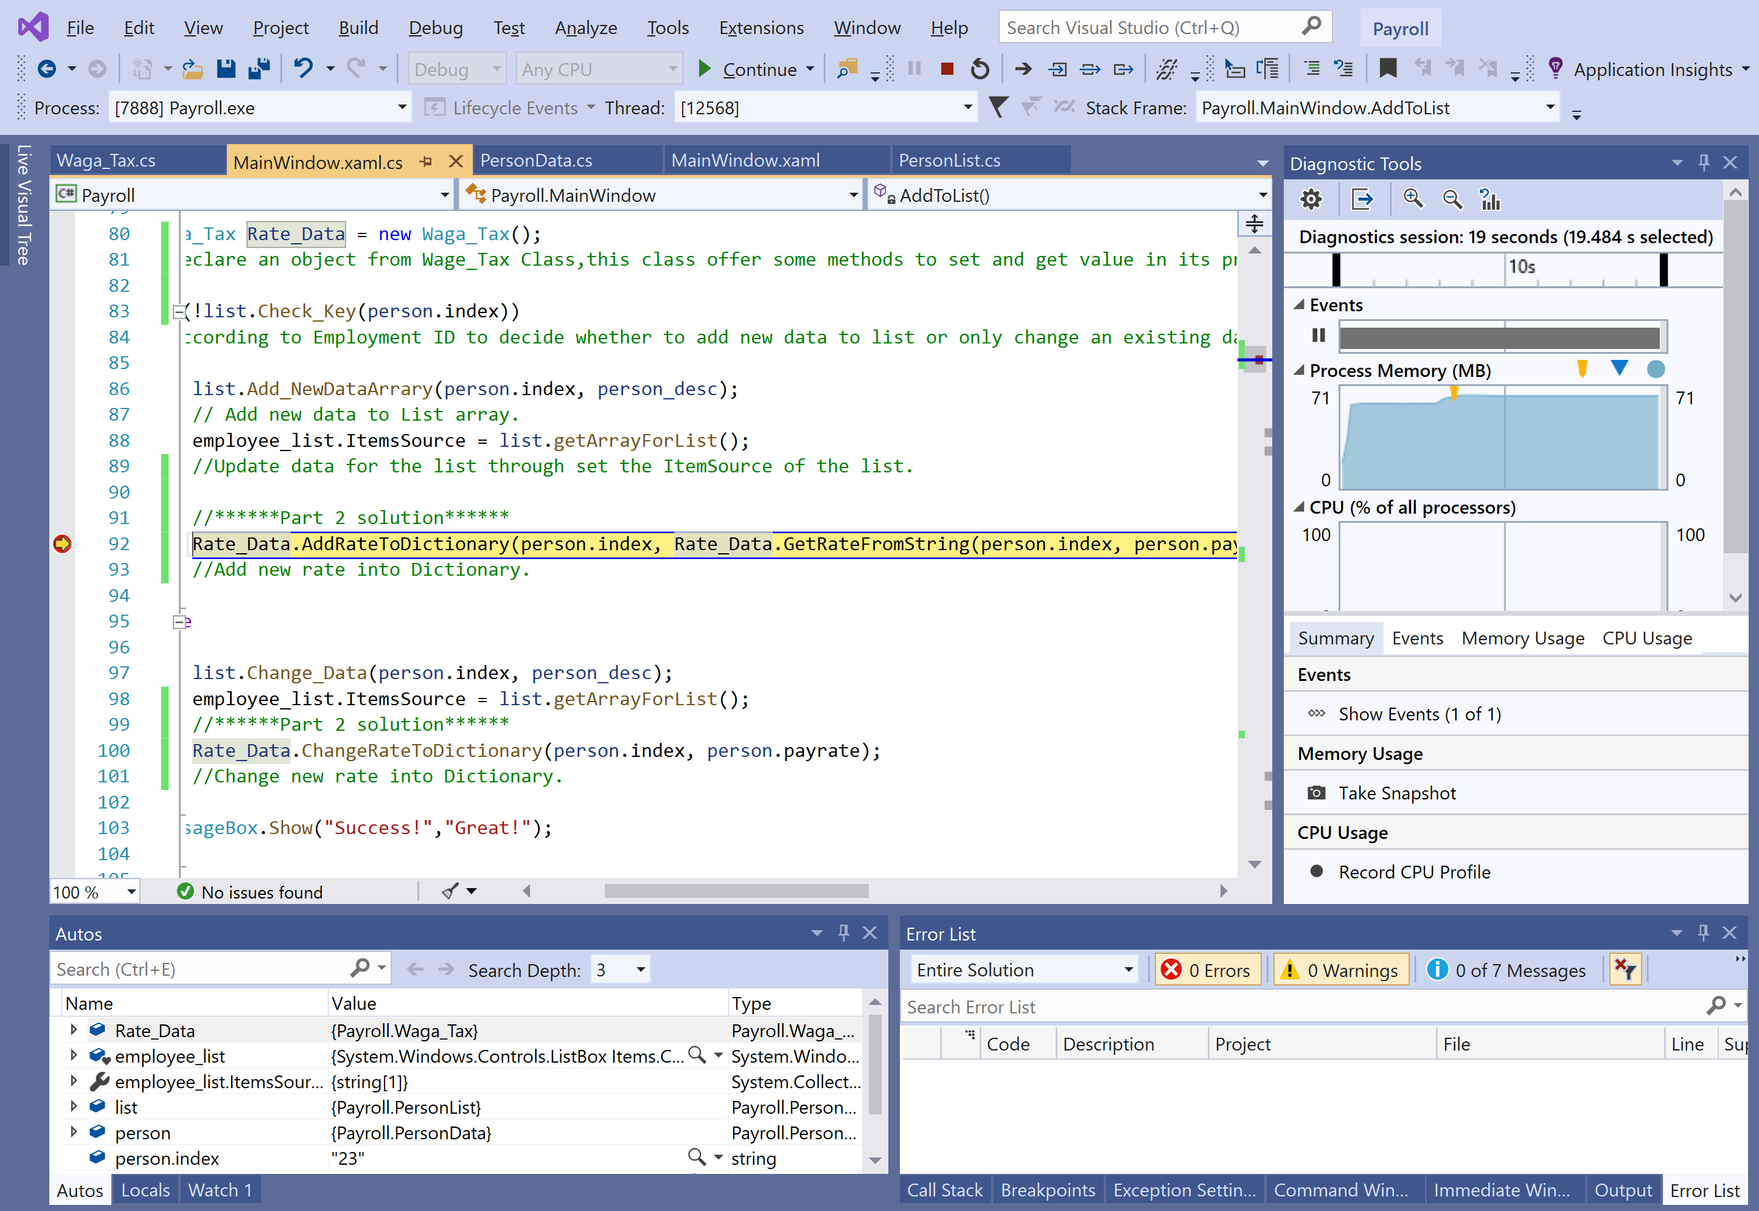

# Part 3

|  |  |  |  |  |
| --- | --- | --- | --- | --- |
| Test ID | Test case scenario | Input | Expected output | Actual output |
| 1 | User enters a number which le | -10 | The number must be greater than 0. | No |
| 2 | User enters decimal number to calculate Tax | 4000 | For wage before tax : 4000  Tax Code is : F  Tax Rate is 0.30  Tax Deduction is $219  Weekly Tax is $981.00  New wage after Tax is $3019.00 | Yes |
| 3 | User enters String letter to calculate Tax | abcd | Only accept Wages type as number | Yes |

